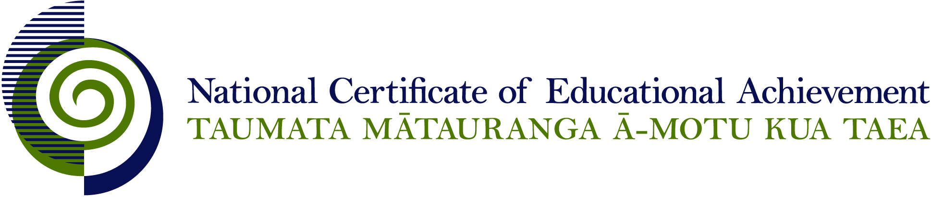

NCEA Level 3 History

Conditions of Assessment

General Information

Subject Reference | Social Science Studies
Domain | History
Level | 3

Conditions of Assessment

These Conditions provide guidelines for assessment against internally assessed Achievement Standards. Guidance is provided on:
- specific requirements for all assessments against this Standard
- appropriate ways of, and conditions for, gathering evidence
- ensuring that evidence is authentic.

Assessors must be familiar with guidance on assessment practice in learning centres, including enforcing timeframes and deadlines. The NZQA website offers resources that would be useful to read in conjunction with these Conditions of Assessment.

The learning centre’s Assessment Policy and Conditions of Assessment must be consistent with NZQA’s Assessment Rules for Schools with Consent to Assess. This link includes guidance for managing internal moderation and the collection of evidence.

Gathering Evidence

Internal assessment provides considerable flexibility in the collection of evidence. Evidence can be collected in different ways to suit a range of teaching and learning styles, and a range of contexts of teaching and learning. Care needs to be taken to allow students opportunities to present their best evidence against the Standard(s) that are free from unnecessary constraints.

It is recommended that the design of assessment reflects and reinforces the ways students have been learning. Collection of evidence for the internally assessed Standards could include, but is not restricted to, an extended task, an investigation, digital evidence (such as recorded interviews, blogs, photographs, or film), or a portfolio of evidence.

Effective assessment should suit the nature of the learning being assessed, provide opportunities to meet the diverse needs of all students, and be valid and fair.

Ensuring Authenticity of Evidence

Authenticity of student evidence needs to be assured regardless of the method of collecting evidence. This must be in line with the learning centre’s policy and NZQA’s Assessment Rules for Schools with Consent to Assess.

Ensure that the student’s evidence is individually identifiable and represents the student’s own work. The evidence must be an accurate reflection of what the student independently knows and can do, according to the Standard being assessed. This includes evidence submitted as part of a group assessment, evidence produced outside of class time or without assessor supervision, and evidence produced with any use of generative artificial intelligence tools (GenAI). GenAI use should be carefully considered in the context of the Standard being assessed and its Conditions of Assessment, discussed with students before the assessment, and its use must be acknowledged. For example, an investigation carried out over several sessions could include:
- teacher guidance on the nature and extent of acceptable GenAI use, if any
- assessor observations and conversations
- meeting with the student at set milestones or checkpoints
- the student’s record of progress, such as photographic entries or any GenAI prompts used.

Specific Information for Individual Internal Achievement Standards
Achievement Standard Number | 91434 History 3.1
Title | Research an historical event or place of significance to New Zealanders, using primary and secondary sources
Number of Credits | 5
Version | 4

An event can be researched in a personal, local, national, or international context.

At this level it is expected that the teacher will take on a mentoring role to provide guidance and support to the students throughout the research process. This could include providing feedback on the suitability of the research topic and the focusing questions, and guiding the student towards appropriate sources.

Evidence for this achievement standard would be expected to be gathered from in and out of class activities to be completed by students over a period of time specified by the teacher. Where a group approach is used the teacher needs to ensure that there is evidence that each student has met all aspects of the standard.

This evidence may be generated from discussion, group work, research, decision making and/or reflection and will be presented in any media that clearly communicates the student’s understanding of the inquiry.

Achievement Standard Number | 91435 History 3.2
Title | Analyse an historical event, or place, of significance to New Zealanders
Number of Credits | 5
Version | 3

Evidence for this achievement standard would be expected to be gathered from in and out of class activities to be completed by students over a period of time specified by the teacher. Where a group approach is used the teacher needs to ensure that there is evidence that each student has met all aspects of the standard.

This evidence may be generated from discussion, group work, research, decision making and/or reflection and will be presented in any media that clearly communicates the student’s understanding of the inquiry.

Students must have access to research materials in order to complete their analysis. While the format of the presentation of evidence is not assessed, teachers should ensure that any format specified provides students the opportunity to reach the standard required.

Achievement Standard Number | 91437 History 3.4
Title | Analyse different perspectives of a contested event of significance to New Zealanders
Number of Credits | 5
Version | 2

This standard could be assessed in conjunction with History 3.1.

It is appropriate for students to investigate an historical debate, not adopt an historical role. The requirements to evaluate validity would make it difficult for a task where students adopt personas to meet the achievement criteria.

Evidence for this achievement standard would be expected to be gathered from in and out of class activities to be completed by students over a period of time specified by the teacher. Where a group approach is used the teacher needs to ensure that there is evidence that each student has met all aspects of the standard.

The student must use accurate and authentic historical information as the basis of their evidence. This evidence may be generated from discussion, group work, research, decision making and/or reflection and will be presented in any media that clearly communicates the student’s understanding of the different perspectives of a contested event.

Teachers will need to provide guidance and opportunities for discussion surrounding the event and perspectives on it. Students must have access to relevant materials and teachers should provide direction on where this material can be found.

